QUESTIONNAIRE

for ordering a grip block for cages type PTKA _______________
TUU 28.2-37296011-010:2020
(indicate the standard size according to the section 4 of the questionnaire)
Customer Information:

Pit, association, mine, lift (shaft): _________________________________________________

_______________________________________________________________________________
Еmail: ________________________________________________________________________

Phone/fax: ___________________________________________________________________
Contact person (name, position, tel.): _____________________________________________
_____________________________________________________________________________
_____________________________________________________________________________
_____________________________________________________________________________
_____________________________________________________________________________
_____________________________________________________________________________

________________________________________________(Customer)

________________________________________(project organization)
L.S.
_____

_____________________________(date of questionnaire preparation)

1 Working conditions:
Item No. | Parameter name | UOM | Response
1 | Water abundance in the operation area of the product* | m³/h
2 | Mine water aggressiveness* | рН
3 | Results of analytical control of mine waters
 | (with a list of controlled substances) of sanitary -
 | preventive laboratory * | -
4 | Climatic version (U/T) | -

* - these fields do not have to be filled. To be filled in if necessary.

2 Hardware requirements
2.1 General data of the hoisting unit:
Item No. | Parameter name | UOM | Response
1 | As a part of which hoisting unit is used | -
2 | Which cage is used with | -
3 | As a part of which suspension device is used | -

3 Initial data and design parameters of the grip block
Item No. | Questions | Responses | Calculation formulas
1 | Standard size of the ordered grip block in accordance with the table (section 3) |  | 1.  $\text{Scт}\text{.} \text{тах}=\frac{g}{\text{1000}}×\left(Q+\text{Qyp}\right)$  2. For standard sizes of grip blocks without block coupling  $$\text{Rа}=\frac{g}{\text{1000}}×\left(\frac{(Q+\text{Qyp})×( j/g+1)}{1,2×m}+\text{Pk}×L\right)$$  3. For standard sizes of grip blocks with block coupling:  3.1 For 1st directly mounted shock absorber  $$\text{Rа}=\frac{g}{\text{1000}}×\left(\frac{(Q+\text{Qyp})×( j/g+1)}{1,2×m}+\text{Pk}×L\right)$$  3.2 For each of a pair of shock absorbers installed through a block coupling  $R^{'}а=\frac{1}{2}×\frac{g}{\text{1000}}×\left(\frac{(Q+\text{Qyp})×( j/g+1)}{1,2×m}+\text{Pk}×L\right)$g = 9.8 m/s2 - gravity acceleration  j = 6 m / s2 - accepted deceleration of the mine cage  m = 2 - number of brake cable ropes
2 | Distance between the axles of brake cable ropes, mm
3 | Required number of sets, pcs.
4 | Shock absorber static resistance,  Rа / R¹а, kN
5 | What standard size of the suspension gear is it used with
6 | Mine cage type (non-tilting, tilting),  designation
7 | Weight of the cage with the maximum load, including the weight of the grip block safety hook and the suspension gear Q, kg
8 | Weight of the balancing cable rope Qb, kg
9 | Weight of 1st running meter of brake cable rope  Рr, kg / m
10 | Estimated length of the brake cable L, m (from the tensioner to the coupling)
11 | Cage movement speed, m/s
12 | Actual maximum static load Sst max, kN
13 | Is the supply of a switching device required (only for tilting cages for grip blocks of standard sizes PTKA 12.5.000 - 01.04; 01.08; 02.04; 02.08) (yes / no)

4 Main parameters and dimensions of mine grip blocks for PTKA cages
grip block size and type designation |  | Distance between axles of brake cable ropes L, mm | Static load,  max  kN | Brake cable rope diameter d_{r}, mm | Weight, kg
 |  |  |  |  | grip block |  | delivery set |  | Safety hook
without block coupling | with block coupling | Distance between axles of brake cable ropes L, mm | Static load,  max  kN | Brake cable rope diameter d_{r}, mm | without block coupling | with block coupling | without block coupling | with block coupling | Safety hook
PTKA 6.3.000-01.01 | PTKA 6.3.000-02.01 | 1150 | 63 | 25.5 | 845 | 1265 | 1070 | 1460 | 170
-01.02 | -02.02 | 1,200
-01.03 | -02.03 | 1480 |  |  |  |  |  |  | 200
PTKA12.5.000-01.01 | PTKA12.5.000-02.01 | 1015 | 125 | 30.5 | 1100 | 1501 | 1541 | 1942 | 412
-01.02 | -02.02 | 1150 | 125 | 30.5 | 1121 | 1524 | 1565 | 1965 | 435
-01.03 | -02.03 | 1,200
-01.04 | -02.04 | 1350 | 125 | 30.5 | 1164 | 1565 | 1605 | 2006 | 476
-01.05 | -02.05 | 1480 | 125 | 30.5 | 1150 | 1550 | 1590 | 1990 | 460
-01.06 | -02.06 | 1540
-01.07 | -02.07 | 1630 | 125 | 30.5 | 1155 | 1556 | 1596 | 1997 | 467
-01.08 | -02.08 | 1730 | 125 | 30.5 | 1182 | 1583 | 1623 | 2024 | 495
PTKA20.000-01.01 | PTKA20.000-02.01 | 1150 | 200 | 35 | 2025 | 2570 | 2715 | 3260 | 575
-01.02 | -02.02 | 1,200
-01.03 | -02.03 | 1350 | 200 | 35 | 2040 | 2585 | 2730 | 3275 | 590
-01.04 | -02.04 | 1540 | 200 | 35 | 2065 | 2610 | 2755 | 3300 | 615
-01.05 | -02.05 | 1630 | 200 | 35 | 2075 | 2620 | 2765 | 3310 | 625
-01.06 | -02.06 | 1680 | 200 | 35 | 2085 | 2630 | 2775 | 3320 | 635
-01.07 | -02.07 | 1730
-01.08 | -02.08 | 1870 | 200 | 35 | 2105 | 2650 | 2795 | 3340 | 655
-01.09 | -02.09 | 1980 | 200 | 35 | 2010 | 2555 | 2700 | 3245 | 560
PTKA25.000-01.01 | PTKA25.000-02.01 | 1540 | 250 | 40 | 2275 | 2960 | 3010 | 3695 | 742
-01.02 | -02.02 | 1630 |  |  |  |  |  |  | 756
-01.03 | -02.03 | 1680
-01.04 | -02.04 | 1780 | 250 | 40 | 2295 | 2985 | 3030 | 3720 | 770
-01.05 | -02.05 | 1870 |  |  |  |  |  |  | 780
PTKA30.000-01.01 | PTKA30.000-01.01 | 1040 | 300 | 45 | 2330 | 3020 | 3050 | 3740 | 850
-01.02 | -02.02 | 1080
-01.03 | -02.03 | 1150 | 300 | 45 | 2340 | 3030 | 3060 | 3750 | 860
-01.04 | -02.04 | 1500 | 300 | 45 | 2370 | 3060 | 3090 | 3780 | 891
-01.05 | -02.05 | 1630 | 300 | 45 | 2390 | 3081 | 3110 | 3801 | 912
-01.06 | -02.06 | 1780 | 300 | 45 | 2415 | 3106 | 3135 | 3826 | 937
-01.07 | -02.07 | 1870 | 300 | 45 | 2426 | 3117 | 3146 | 3837 | 948

5 Delivery requirements:
Item No. | Parameter name | UOM | Response
1 | Number of ordered products | pcs.
2 | Spare parts set:
 | - basic | - | Yes No
 | - individual | - | Yes No
 | (describe the desired set)
3 | Availability of packaging containers | - | Yes No

5.1 Additional delivery requirements:
Item No. | Parameter name | UOM | Response
1 | Basic anti-corrosion coating | - | Yes No
2 | Additional anti-corrosion coating | - | Yes No
 | (describe the desired coating)

An example of a designation of a grip block with a grip on the brake cable ropes for a static load of 63 kN without a block coupling in climatic version U:
Grip block PTKA6.3-01.07 TUU 28.2-37296011-010: 2020

grip block with a grip on the brake cable ropes for a static load of 125 kN with a block coupling in climatic version U:
Grip block PTKA12.5-02.07 TUU 28.2-37296011-010: 2020

6 Grip block for PTKA mine cages
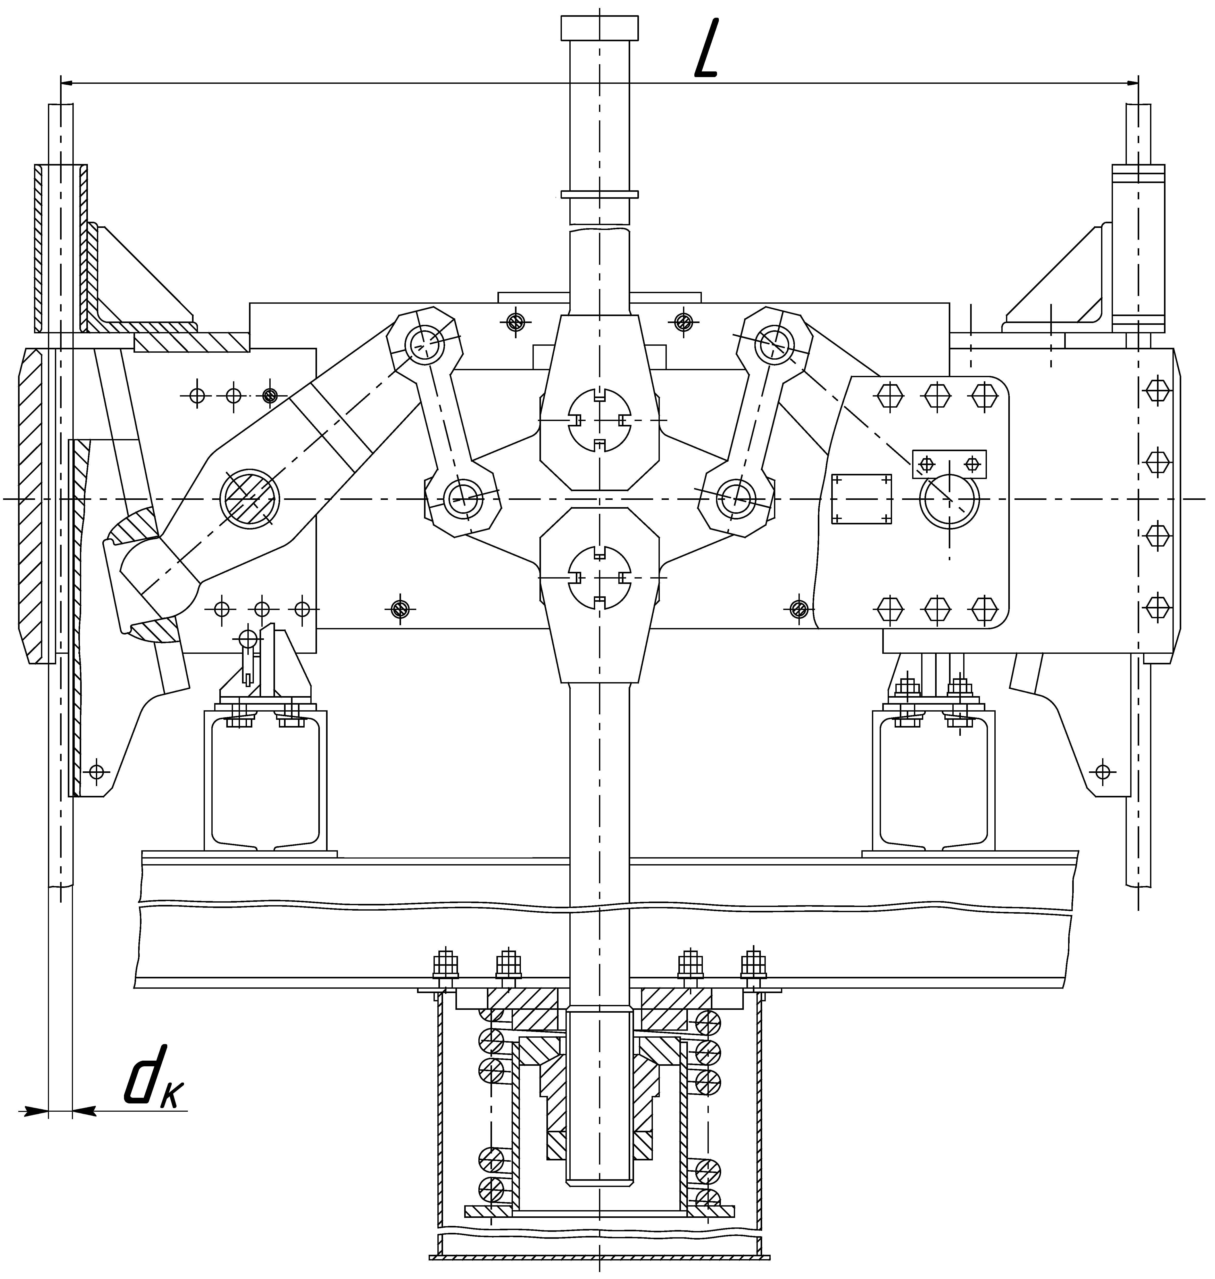
Safety hook
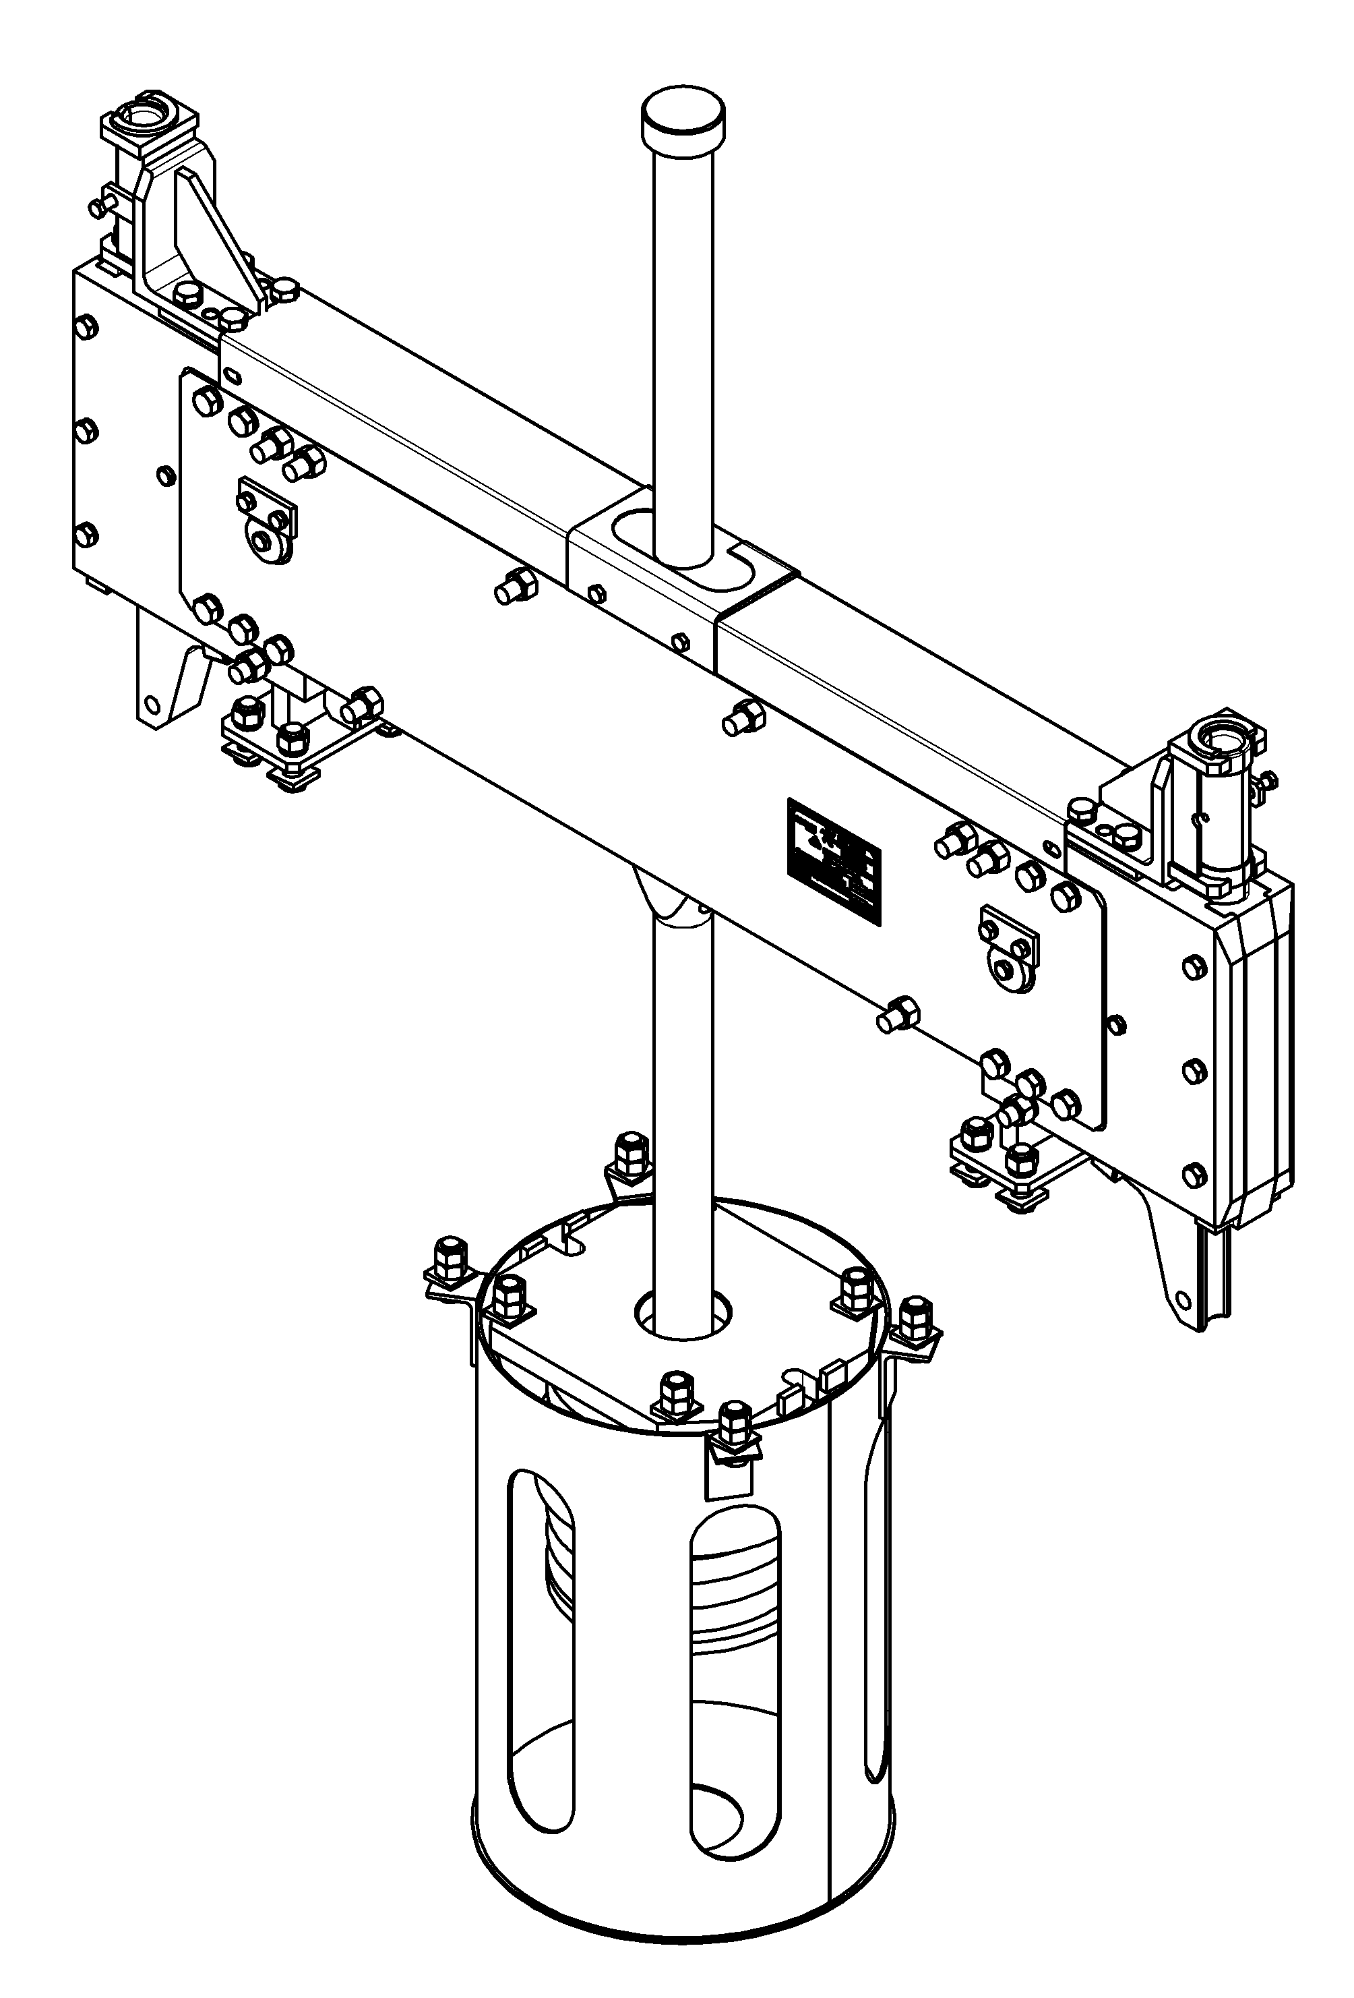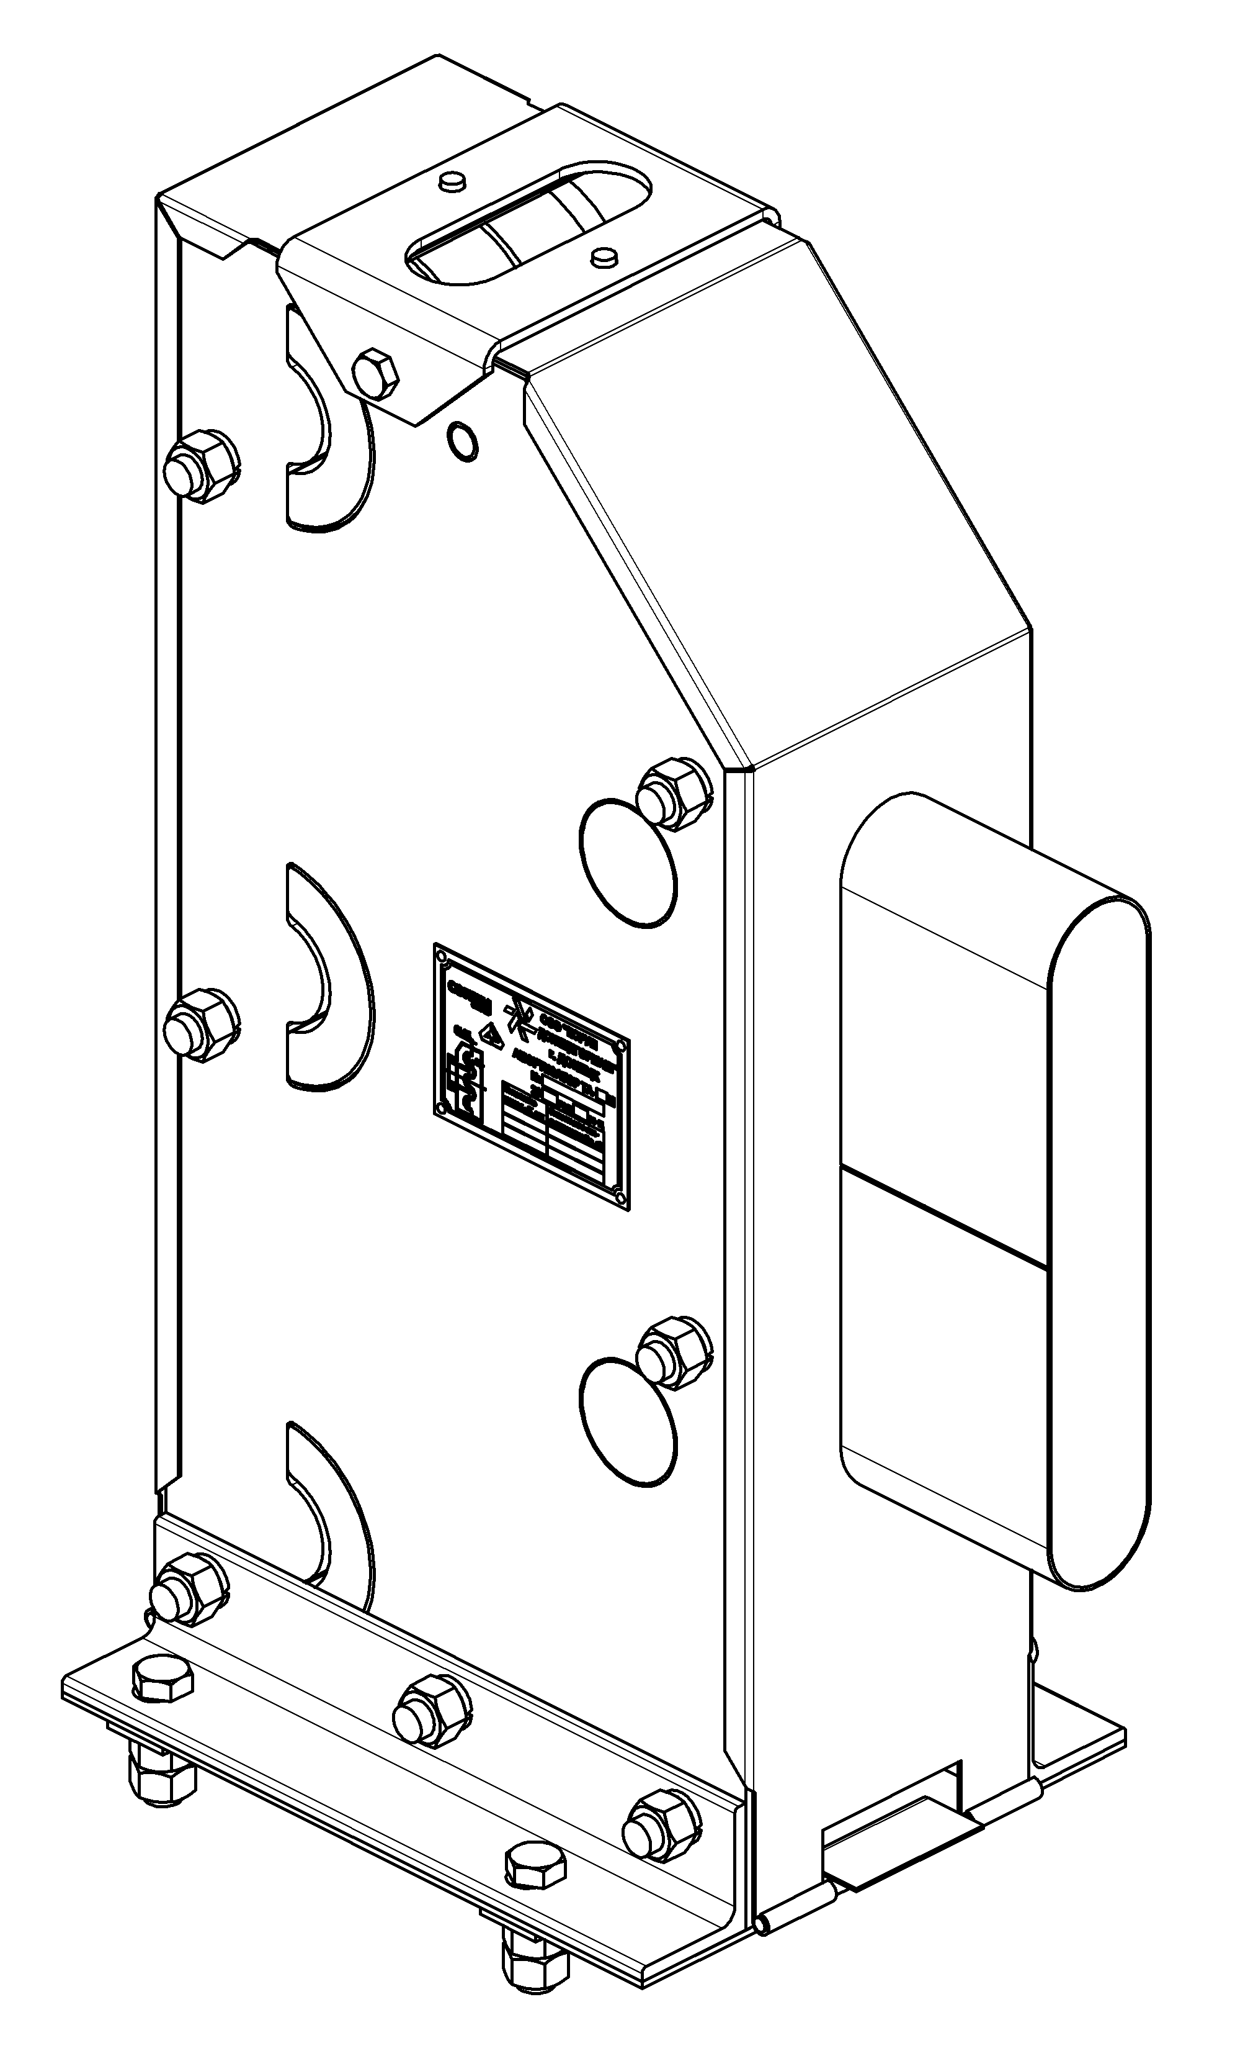
Safety hook Shock absorber

